1.Выведите данные на **cart-page** из таблицы **carts**:

**resources\views\shop\cart.blade.php**

@include(**'shop.cart-standard'**)

**resources\views\shop\cart-standard.blade.php**

@foreach(**$carts as $cart**)

…

<img src="{{ **asset('public/img/' . $cart->image)** }}" alt="Product">

<h5>**{{$cart->name}}**</h5>

<span>$**{{$cart->price}}**</span>

…

@endforeach

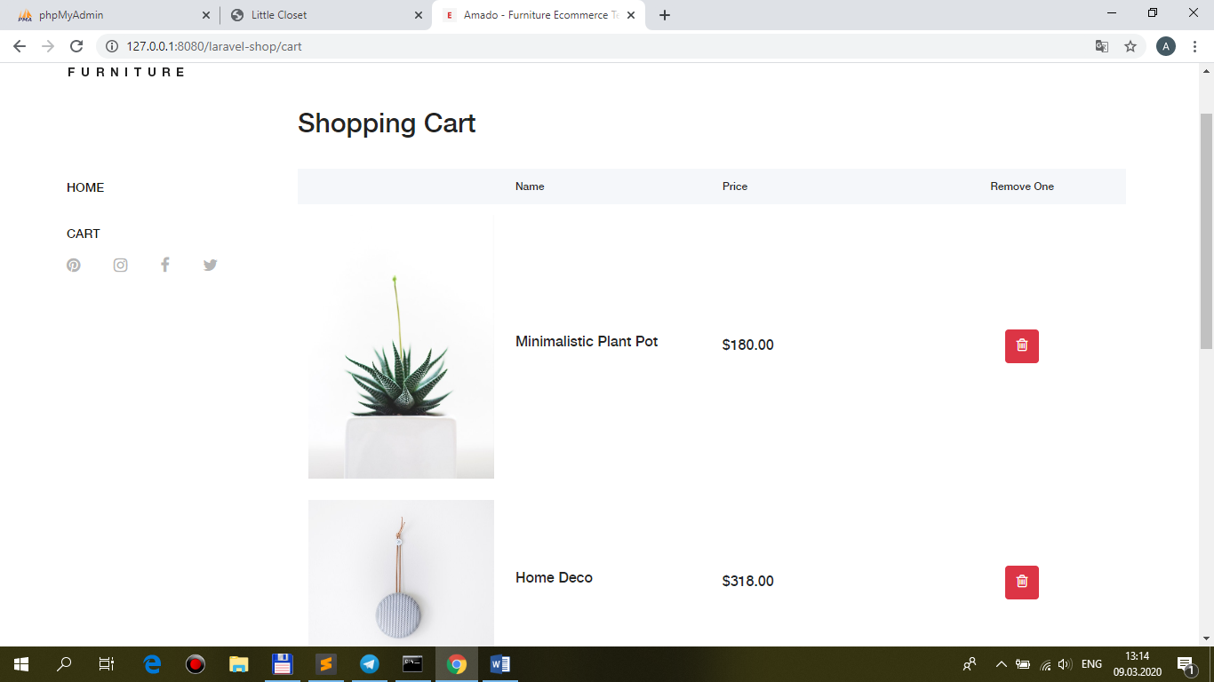

2.Реализуйте **submit-очистку всей** корзины:

**resources\views\shop\cart-standard.blade.php**

<button type="button" **class="btn btn-danger w-100"**>Clear all Cart</button>

**<form name="form_clearall" method="post" action="{{route('clearall')}}">**

**{{ csrf_field() }}**

**</form>**

…

**section('js')**

**<script>**

**$(document).ready(function(){**

**$('.btn.btn-danger.w-100').click(function(){**

**form_clearall.submit();**

**});**

**});**

**</script>**

**@endsection**

**routes\web.php**

Route::**name('clearall')->post('/clearall', 'ShopController@clearall');**

**app\Http\Controllers\ShopController.php**

use App\ {

…

**Models\Cart,**

…

};

/**

* **Destroy all cart**.

*

* @return \Illuminate\Contracts\Support\Renderable

*/

public function **clearall(Cart $cart)**

**{**

**$cart->truncate();**

**return redirect(route('cart'));**

}

